- Anonymous- (adj) unnamed, without the name of a person involves (writer, composer, etc,); unknown; lacking individuality or character
Syn. - nameless

Prompt: Describe a circumstance in which someone may want to remain anonymous.

- Browse- (v) to nibble, graze; to read casually; to window-shop
Syn. - skim, scan, dip, into, graze
Ant. - pore over, scrutinize

Prompt: If you browse over the article of the week, will you remember the small details?

- Dupe- (N) a person easily tricked or deceived; (V) to deceive
Syn. - fool, mislead, hoodwink, delude
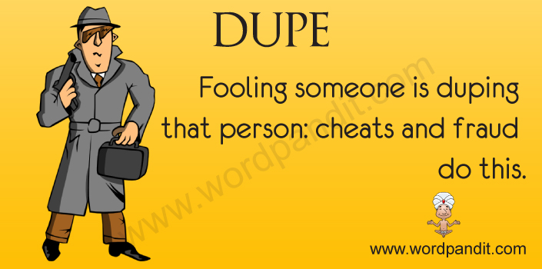
Prompt: Write the name of a fictional character (movie or book) that has been duped.

- Dynamic- ( adj) active, energetic, forceful
Syn. - vigorous, high-powered
Ant. - lazy, lackadaisical, lethargic, sluggish
Prompt: Dynamic players are needed for what three sports?

- Eradicate- (v) to root out, get rid of, destroy completely
Syn. - wipe out, uproot
Ant. - implant, instill, foster, promote
Prompt: If doctors were to eradicate Ebola, how many people would have it?

- Frustrate- (V) to prevent from accomplishing a purpose or fulfilling a desire; to cause feelings of discouragement
Prompt: What activity makes you feel frustrated?

- Grim (adj)- stern, merciless; fierce, savage, cruel
Syn. - dreadful, frightful, ferocious
Ant. - mild, merciful, delightful

Prompt: What holiday might some people associate with the word grim?

- Inimitable- (Adj)- not capable of being copied or imitated
Syn. - matchless, incomparable, unique

Prompt: What is one quality you possess that is inimitable?

- Makeshift- (n)- a temporary substitute for something else; (adj) crude, flimsy, or temporary
Syn- (n) - stopgap, substitute
Ant. - (adj) - permanent, durable, solid, sturdy
Prompt: If there weren’t any available, what could be used as a makeshift chair? Makeshift chair =

- Marginal- (adj)- in, at, or near the edge or margin; only barely good, large, or important enough for the purpose
Syn. - borderline, minimal, peripheral
Ant. - central, pivotal, focal
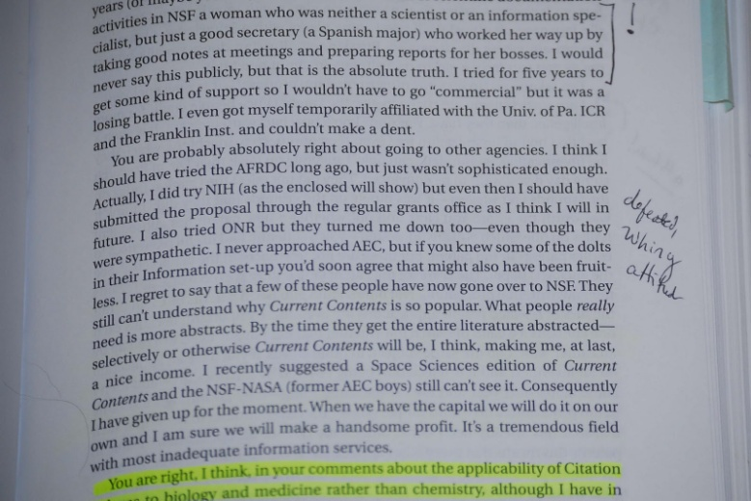
Prompt: Throughout history, what is one group of people that has been marginalized?

