11. Pending- (adj) - waiting to be settled; (prep) - until
Syn. - (adj) - undecided, unsettled
Ant. - (adj) - settled, decided, resolved
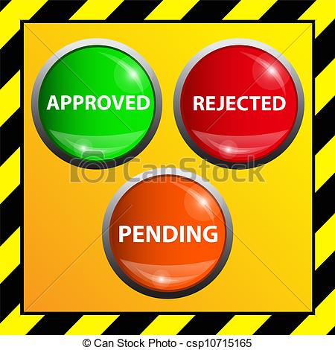
Prompt: Write pending in a sentence with context clues.

12. Prescribe- (v) - to order as a rule or course to be followed; to order for medical purposes
Syn. - specify, appoint, recommend
Prompt: Who prescribes medication?

13. preview- (N) - something seen in advance; (v) - to view beforehand
Syn- (n) - foretaste
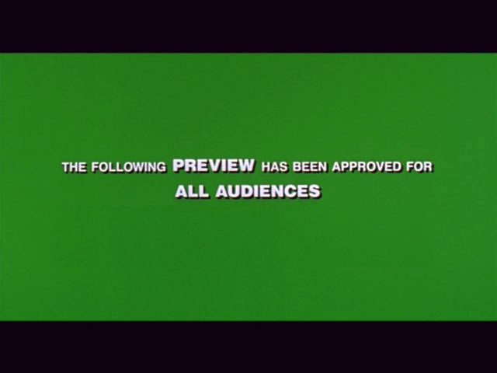
Prompt: When do you usually see upcoming movie previews?

14. Prominent- (Adj) - standing out so as to be easily seen; important, well-known
Syn- conspicuous, noticeable
Ant. - inconspicuous, unnoticeable, obscure
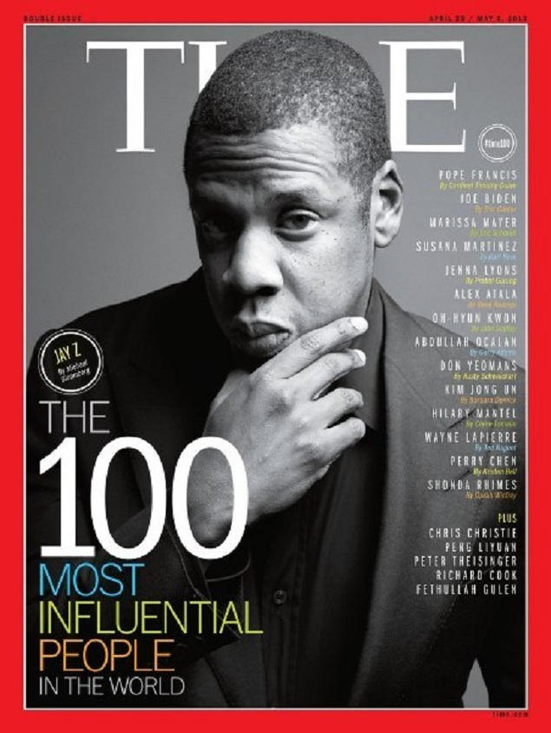
14. Prominent- Prompt: List three prominent celebrities, politicians, or sports stars.

15. Quaint- (adj) - odd or old-fashioned in a pleasing way; clever, ingenious; skillfully made
Syn. - picturesque, peculiar; strange, curious
Ant. - familiar, commonplace, modern, contemporary
Prompt: Write quaint in a complete sentence with context clues.

16. Reluctant- (adj) - unwilling, holding back
Syn. - hesitant, loath, disinclined
Ant. - willing, eager, inclined
Prompt: Language arts teachers think of strategies for reluctant readers. What is a reluctant reader? What is one strategy that a language arts teacher may use to help?

17. Scrimp- (v) - to handle very economically or stingily; to supply in a way that is small, short, or scanty
Syn. - economize
Ant. - splurge
Prompt: What is something you are scrimping and saving for?

18. snare- (V) - to trap, catch; (n) - a trap or entanglement
Syn. - (n) - pitfall; (v) - entrap
Ant- liberate
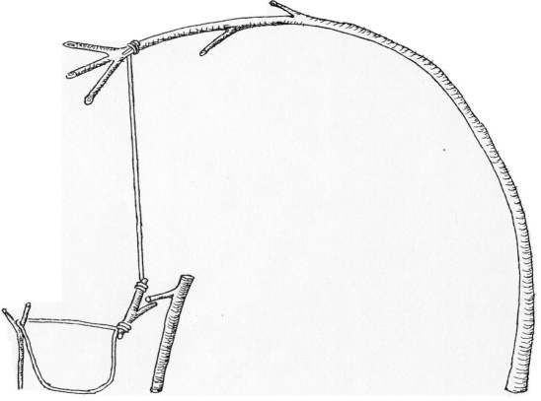
Prompt: What’s a good tool for snaring fish?

19. utmost- (adj) - greatest, highest, farthest; (n) - the extreme limit
Syn- (adj., N.)- Maximum, supreme, best
Ant. - least
Mount Everest
Prompt: Please use the utmost caution when walking on __________________.

20. vengeance- (N) - punishment in return for an injury or a wrong; unusual force or violence
Syn- revenge, retaliation, reprisal
Ant. - forgiveness, pardon
Prompt: Name a character in a movie or book who was vengeful. What were they vengeful about?

