Vocab B Unit 1 Part 1

adjacent- near, next to, adjoining
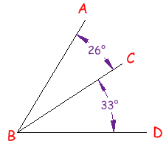

Syn: alongside, nearby, neighboring Ant: faraway, distant, remote

Prompt: List places that are adjacent to WFRMS.

alight - to get down from, or lighted up
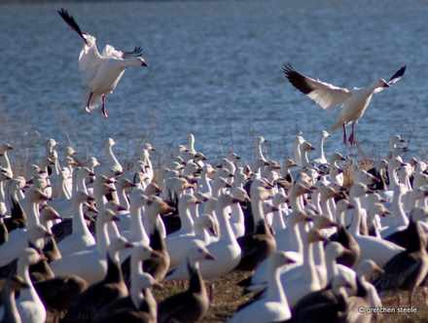

Syn: dismount, descend, land, touch down
Ant: mount, ascend, board, takeoff

Prompt: Describe how the geese alighted on the pond.

barren - not productive, bare
Syn: unproductive, sterile, desolate, arid
Ant: fertile, productive, fruitful

disrupt - to break up, disturb
Syn: upset, displace, disorder
Ant: organize, arrange

dynasty - a powerful family or group that stays in power for some time
Syn : ruling house, regime

foretaste- an advance indication, sample or warning
The cold day was a foretaste of winter.
Syn: preview, anticipation

Germinate -to begin to grow, come into being
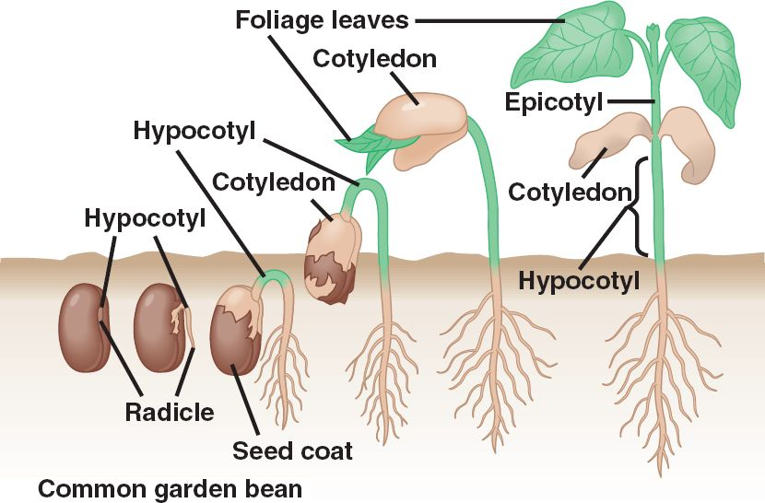
Syn: sprout, shoot up, grow, burgeon Ant: stagnate, shrivel up

humdrum - ordinary, dull, routine, without variation
Syn: monotonous, uneventful
Ant: exhilarating, lively, exciting

hurtle - to rush violently, dash headlong
Syn: speed, fly, race, catapult, fling Ant: crawl, creep

insinuate - to suggest or hint slyly
Syn: imply, intimate
Ant: barge in, broadcast

