Available (adj.) Ready for use, at hand.

Syn: obtainable, on hand
Ant: unobtainable, not to be had

Prompt: What is the earliest time you are available to hang out with on a Saturday morning?

Cater (v.) to satisfy the needs of, try to make things easy and pleasant; to supply food and service.
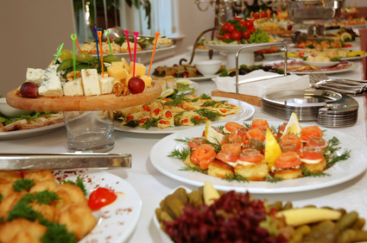
Syn: pamper, indulge, gratify, provide
Ant: frustrate, deny, refuse

Prompt: Explain why a parent should not cater to everything their child wants.

Customary (adj.) usual, expected, routine.
Syn: regular, normal, traditional
Ant: strange, odd, unusual, untraditional

Prompt: What does a customary Saturday look like in your family?

Dissuade (v.) to persuade not to do something.
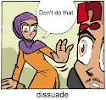
Syn: discourage, talk out of
Ant: persuade, talk into

Prompt: How would you dissuade an adult to stop smoking?
Entrepreneur (n.) a person who starts up and takes on the risk of a business
Syn: businessperson, impresario

Prompt: If you were to become an entrepreneur, what type of business would you start?
Firebrand (n.) a piece of burning wood; a troublemaker; an extremely energetic or emotional person.
Syn: hothead, agitator, rabble-rouser
Ant: peacemaker, pacifier, conciliator

Prompt: What cause would you be a firebrand for?
Hazard (n.) risk, peril; (v.) to expose to danger or harm; to gamble
Syn: danger, venture

Prompt: List three things that can be hazardous to your health.

Homicide (n.) the killing of one person by another
Syn: manslaughter, murder

Prompt: What do you think the punishment for committing homicide should be?

Indifference (n.) a lack of interest or concern
Syn: apathy, unconcern
Ant: interest, concern, enthusiasm

Prompt: How does it make you feel when someone is indifferent toward something you care a lot about?
Indignant (adj.) filled with resentment or anger over something unjust, unworthy, or mean
Syn: offended, resentful, outraged, exasperated
Ant: pleased, delighted, overjoyed, elated

Prompt: What is the last thing you were indignant about?

