11. Indispensable - (adj.) absolutely necessary, not to be neglected
Syn: essential, crucial, vital
Ant: unnecessary, nonessential

Prompt: Describe the skills a basketball player would have that would make them indispensable.

12. Lubricate - (v.) to apply oil or grease; to make smooth, slippery, or easier to use
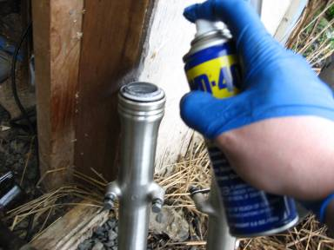
Syn: oil, grease

Prompt: Explain why you might lubricate the hinges on a door.

13 Mutual (adj.) shared, felt, or shown equally by two or more
Syn: two-sided, joint, shared, reciprocal
Ant: one-sided, unilateral
Prompt: Write mutual in a sentence with context clues.
14 Pelt (v.) to throw a stream of things; to strike successively; to hurry
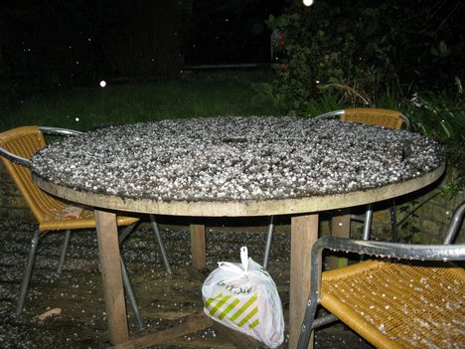
Syn: bombard, shower, pepper
Prompt: How might you feel if your friend pelted your face with snowballs?
15 Plague (n.) an easily spread disease causing a large number of deaths; a widespread evil; (v.) to annoy or bother
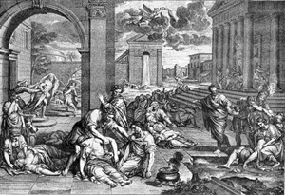
Syn: epidemic, pestilence, pester, vex
Ant: boon, blessing

16 Poised (adj.part.) balanced, suspended; calm, controlled; ready for action
Syn: collected, self-confident, ready
Ant: nervous, tense

17 Regime (n.) a government in power; a form of rule or management
Syn: administration, rule

18 Retard (v.) To make slow, delay, hold back
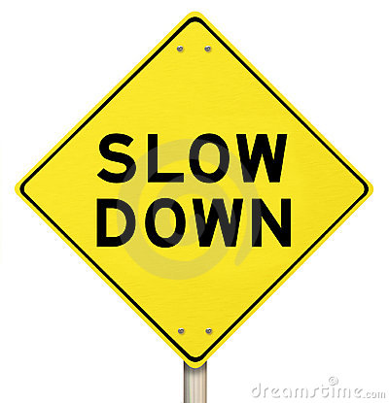
Syn: slow down, restrain, impede
Ant: hasten, speed up

19 Transparent (adj.) allowing light to pass through; easily recognized or understood;
Syn: clear, transluscent, obvious
Ant: frosted, sooty, smoky, unclear, indistinct

20 Unscathed (adj.) wholly unharmed, not injured.
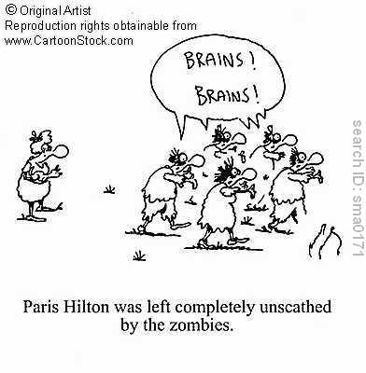
Syn: unhurt, sound, intact, unimpaired
Ant: injured, damaged, harmed, hurt

