Vocab B3 1-10

- animated (adj.) full of life, lively, alive; moved to action
Syn: energetic, vigorous
Ant: dull, lifeless, dead, flat

Prompt: Name the most animated person you know and explain what makes them so.

- brood (n.) a family of young animals, especially birds; any group having the same nature and origin; (v.) to think over in a worried, unhappy way
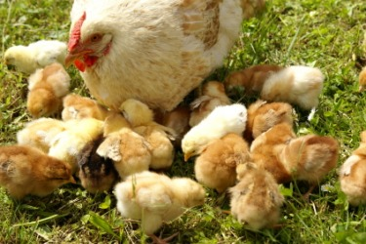
Syn: ponder, meditate, worry, agonize

Prompt: Describe a time when you brooded over something.

- culminate (v.) to reach a high point of development; to end, climax
Syn: conclude, terminate
Ant: begin, initiate, kick off, commence

Prompt: Identify the culminating event of your K-12 education.

- Downright (adv.) thoroughly; (adj.) absolute, complete; frank, blunt

Syn: total, out-and-out, unqualified

Prompt: Who’s the most downright honest person you know? Explain.

- Drone (n.) a loafer, idler; a buzzing or humming sound; a male bee; (v.) to make a buzzing sound; to speak in a dull tone of voice
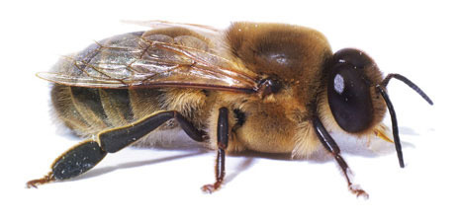
Syn: bum, do-nothing, hum, buzz, purr
Ant: hard worker, workaholic
Prompt: Describe what would happen if a teacher droned on about biophysics.

- goad (v.) to drive or urge on; (n.) something used to drive or urge on
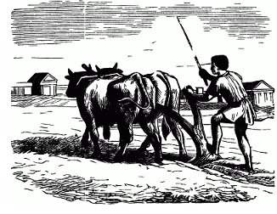
Syn: prod, spur on, incite
Ant: curb, check, restrain

Prompt: What would goad you into working hard to earn straight A’s?

- indulge (v.) to give in to a wish or desire, give oneself up to
Syn: oblige, humor, coddle, pamper
Ant: deny, refuse

Prompt: What candy would you like to indulge in every day?

- ingredient (n.)one of the materials in a mixture, recipe, or formula
Syn: element, component, constituent, factor
Prompt: List the ingredients for your favorite dish.

- literate (adj.)able to read and write; showing an excellent educational background; having knowledge or
training

Syn: educated, trained
Ant: unlettered, unschooled, ignorant

Prompt: Explain why it is important to be literate.

- loom (v.) to come into view; to appear in exaggerated form; (n.) a machine for weaving
Syn: emerge, surface, hover, tower

Prompt: Describe what you would do if you saw a storm looming above your home.

