Alliance - a joining together for some common purpose
Syn: pact, league, coalition
Ant: rift, split

Prompt: If you had to form an alliance of 5 people, who would be on your list?
Bewilder - to puzzle completely, confuse
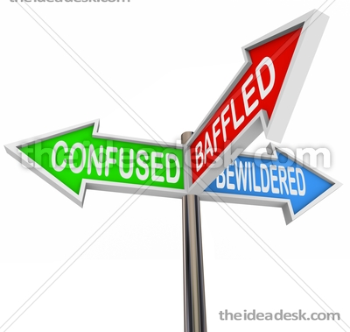
Syn:baffle, perplex
Ant:set straight, enlighten

Prompt: What baffles you?

Buffoon - a clown; a coarse, stupid person
Syn:jester, fool
Ant: (none)

Prompt: Who is the biggest buffoon you know?

Controversial - arousing argument, dispute, or disagreement
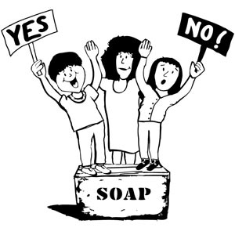
Syn: arguable, debatable
Ant: (none)

Dishearten - to discourage

Syn: dismay, demoralize, dispirit
Ant: encourage, hearten

fruitless not producing desired results, unsuccessful

Syn: useless, vain, unproductive, futile
Ant: productive, effective

hostile unfriendly; unfavorable; warlike, aggressive

Syn: (None)
Ant: friendly, cordial, peaceful

inflammable easily set on fire; easily angered or aroused

Syn:combustible, flammable, excitable
Ant: fireproof, fire-resistant, calm

inflict to give or cause something unpleasant

Syn: deal out, visit upon
Ant: suffer, undergo, sustain

malignant deadly, extremely harmful, evil; spiteful, malicious

Syn: lethal, wicked
Ant: wholesome, beneficial, benign

