anecdote - a short account of incident in someone's life
Syn: tale, story, sketch, yarn, vignette
Ant: none

Prompt: What’s a phrase someone may use when they begin telling an anecdote?
consolidate - to combine ;unite; to make solid or firm
syn. merge, strengthen, firm up
ant. scatter, disperse, dissipate, separate

Prompt: If Target and Walmart were to consolidate, what might their new name be?

counterfeit - an imitation designed to decive; not genuine, fake; to make an illegal copy
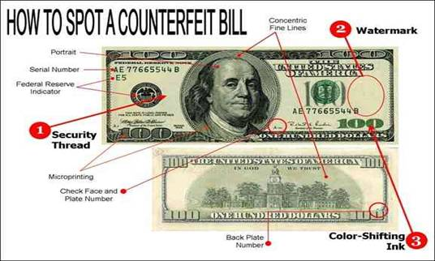

syn. false, phony, bogus
ant. genuine real, authentic

Prompt: How can you tell if an item (purse, sunglasses, etc.) is counterfeit?

docile - easily taught, led, or managed; obedient
syn. manageable, teachable, pliant
ant. unruly, wayward, intractable, disobedient
Prompt: List two animals that are known to be docile and two that are known to be wayward.

dominate - to rule over by strength or power, control; to tower over, command due to height
syn. control, govern, overlook
Ant: none
Prompt: Who would dominate: Michael Jordan or Lebron James?
entreat - to beg, implore, ask earnestly
syn. plead, beseech
ant. clamor for
Prompt: What is something you have entreated your parents for?
fallible - capable of being wrong, mistaken, or inaccurate
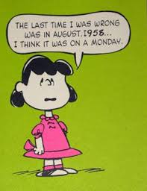

syn. imperfect,errant
ant. foolproof, unfailiing, flawless
Prompt: Name someone who thinks that they are not fallible.

fickle - liable to change very rapidly, erractic; marked by a lack of constancy or steadiness, inconsistent
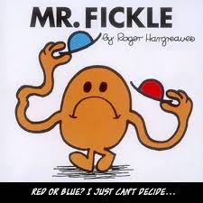
syn. capricious, inconstant, faithless
ant. constant, steady, invariable

Prompt: Describe fickle weather conditions.

fugitive - one who flees or runs away; fleeting, lasting a very short time; wandering; diffcult to grasp
syn. runaway, deserter, elusive
ant. lasting, enduring, permanent

Prompt: What literary genre is most likely to have a fugitive?
grimy - very dirty, covered with dirt or soot
syn. filthy, sooty, dirt-encrusted
ant. spotless, spick-and-span, immaculate

Prompt: What grimy place have you been to? What made it grimy?

