iota - a very small part or quantity
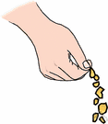

syn. speck, dab, jot, bit, smidgen
ant. flood, deluge, avalanche, glut

Prompt: I hope to have an iota of _____________ at dinner.
maul - to beat or knock about, handle roughly; to mangle; a heavy hammer
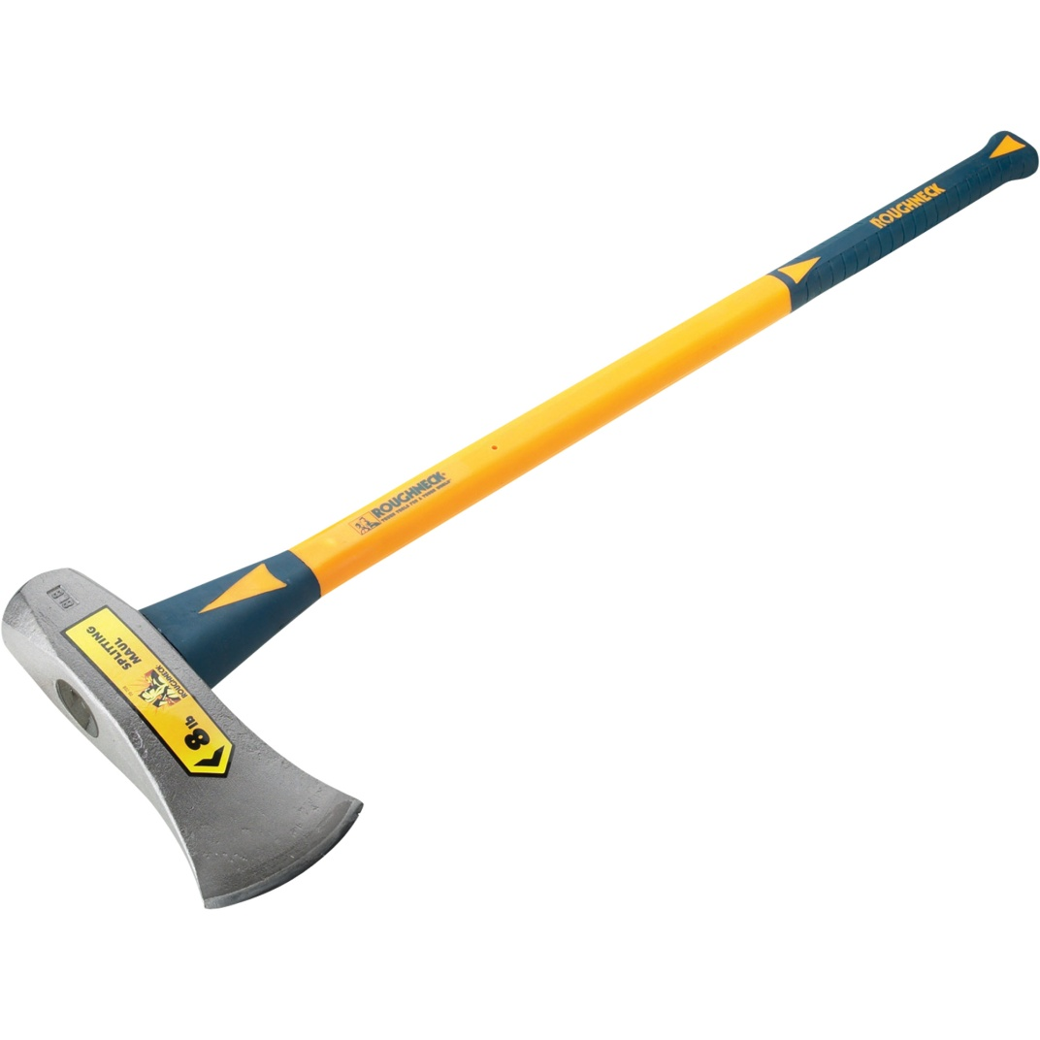
syn. rough up, manhandle, batter

Prompt: What would you do to avoid being mauled by a bear?

potential - possible, able to happen, something that can develop or become a reality
syn. possibility, capability
ant. actual, real, unlikely, impossible

Prompt: What are two things you can do to ensure you reach your full potential?

radiant- shining, bright; giving forth light or energy
syn. glowing, brilliant, dazzling, resplendant
ant. dull, tarnished, lackluster
Prompt: List five things that should be radiant.

rural - relating to farm areas and life in the country
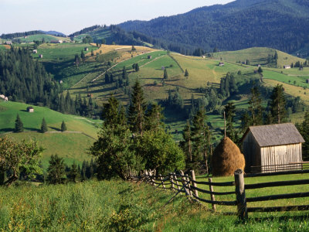

syn. countrified, rustic
ant. urban, metropolitan, citified
Prompt: What are two ways that rural and urban living are different?
substantial - large, important; major, significant; prosperous; not imaginary, material
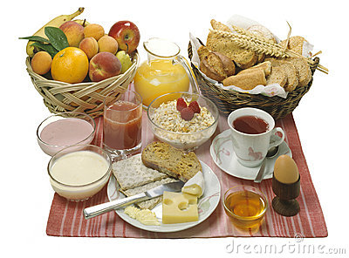

syn. considrable, tangible, big
ant. minor, insignificant, negligible

Prompt: What would you include in order to make breakfast substantial?
tactful - skilled in handling difficult situations or people, polite
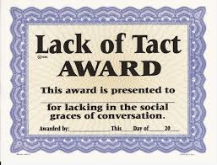

syn. skillful, diplomatic, discreet
ant. clumsy, gauche, boorish, indiscreet
Prompt: Name the most tactful person you know.
tamper - to interfere with; to meddle rashly or foolishly with; to handle in a secret and improper way
syn. to monkey with, fool with, mess with

Prompt: Write tamper in a sentence with context clues.

ultimate - last, final; most important or extreme; eventual; basic, fundamental
syn. farthest, furthest, terminal
ant. first, initial, most immediate, nearest

Prompt: What do you think is the most ultimate sport?
uncertainty - doubt, the state of being unsure
syn. doubtfulness, unsureness, hesitation
ant. sureness, certainty, confidence

Prompt: In which class do you have the most uncertainty?

