- amiss: adjective- faulty, imperfect, not as it should be; adverb- in a mistaken or improper way, wrongly
synonym- awry
antonym- properly

Complete the sentence: I knew something was amiss when…

- brawl: noun- a noisy quarrel or fight; verb- to quarrel or fight noisiliy
synonymn: noun- scuffle, donnybrook
antonym: spar, scrap

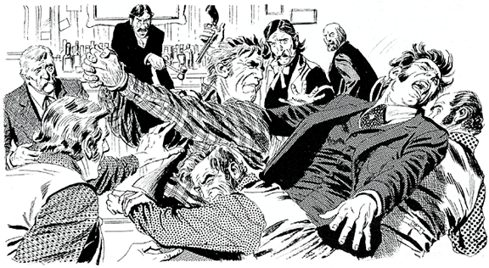
Prompt: List two places where people are more likely to have a brawl.

- detest: verb- to hate, dislike very much, loathe
synonymn- despite, abhor
antonym- relish, love, admire, esteem

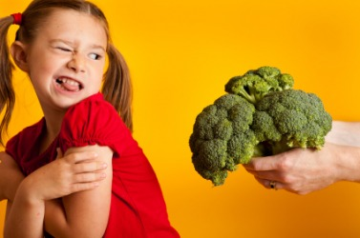
Prompt: What is the food you most detest?

- domestic: adjective- native to a country, not foreign; relating to life or affairs of a household; noun- a household servant
synonym: adjective- household, native; noun- servant
antonym: adjective- foreign, alien

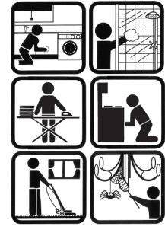
Prompt: What domestic task do you do to help out at home?

- flagrant: adjective- extremely bad, glaring; scandalous, notorious
synonym: blatant, gross, outrageous
antonym: petty, piddling, trifling, inconsequential

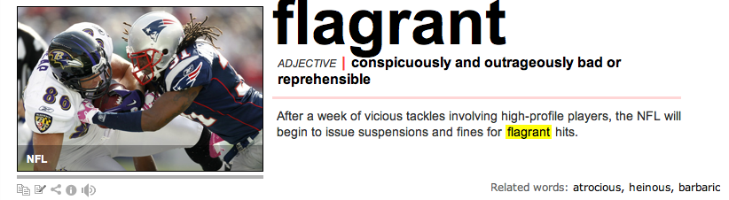
Prompt: What is a flagrant scent?

- flaw: noun- slight fault, defect, crack
synonym: imperfection, blemish
antonym: faultlessness, perfection

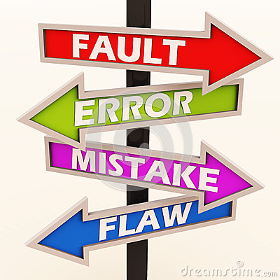
Prompt: The teacher passed out a worksheet and ask the students to find a flaw within each sentence.

- fledgling: noun- an inexperienced person, beginner; a young bird about to leave the nest; adjective- inexperienced, budding
synonym: noun- novice, tyro, neophyte
antonym: noun- pro, expert, veteran

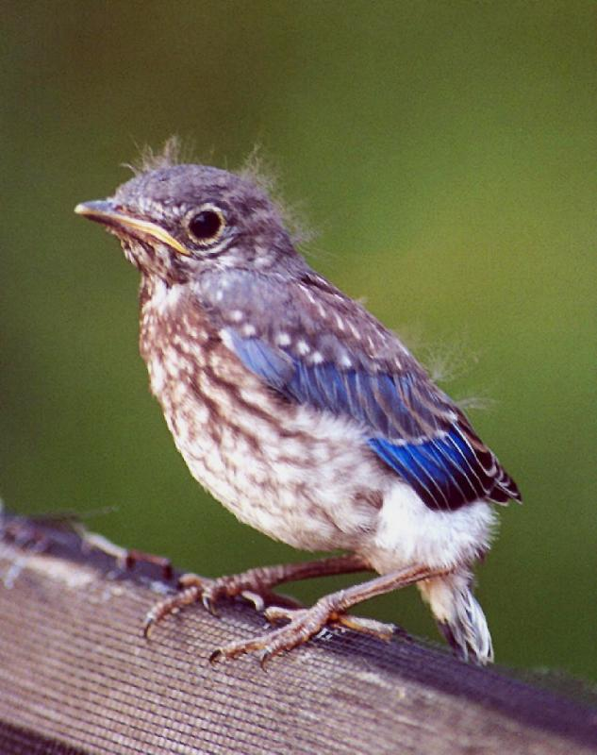
Prompt: What age will you be when you are a fledgling driver?

- fluster: verb-to make or become confused, agitated, or nervous; noun- a state of confusion or agitation
synonym: verb- agitated, rattle, disconcert
antonym: reassure, soothe, quiet

Prompt: What circumstance makes you feel flustered?

- foremost: adjective- chief, most important, primary; adverb- in the first place
synonym: adjective- leading, principal, paramount
antonym: adjective- hindmost, last, secondary

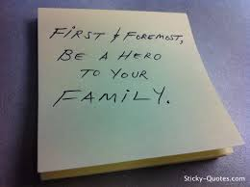
Prompt: What is the foremost characteristic of a hero?

10. momentum: noun- the force or speed with which something moves
synonym: drive, thrust, impetus

Prompt: What is one way a snowball may pick up momentum?

11. notable: adjective- stiking, remarkable; noun- a person who is well known, distinguished, or outstanding in some way
synonym: adjective- noteworthy, impressive
antonym: undistinguished, unremarkable; noun- unknown

Prompt: Who is the most notable person you can think of?

12. nurture: verb- to bring up, care for, train, nourish; noun- rearing, training, upbringing
synonym: verb- raise, rear, foster
antonym: verb- neglect, ignore, discourage, hinder

Prompt: How do you nurture a plant?

13. paradox: noun- a self-contradictory statement that on closer examination proves true; a person or thing with seemingly contradictory qualities
synonym: riddle, enigma, anomaly, absurdity

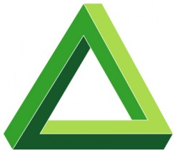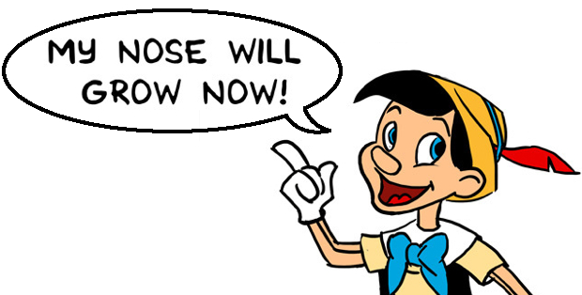

Prompt: Explain why one of the images above is a paradox.

14. perjury: noun- the act of swearing to a lie
synonym: false witness

Prompt: Write perjury in a sentence with context clues.

15. presume: verb- to take for granted, assume or suppose; to dare, take upon oneself, take liberties
synonym: surmise, trespass, infringe
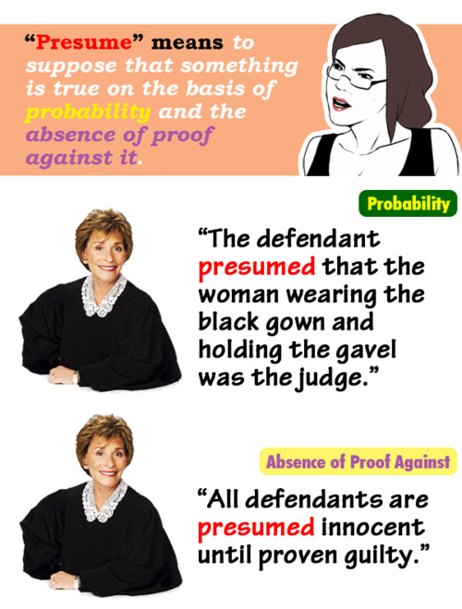
Prompt: What do many students presume is going to happen when the teacher asks them to put everything away but a pencil?

16. proficient: adjective- skilled, expert, or capable in any field or activity
synonym: competent, adept, able
antonym: incompetent, inept, unskilled, ignorant

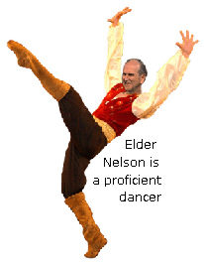
Prompt: I am proficient when it comes to… (list three things).

18. salvo: a burst of gunfire or cannon shot, often as a tribute or salute; a sudden burst of anything; a spirited verbal attack
synonym: barrage, volley

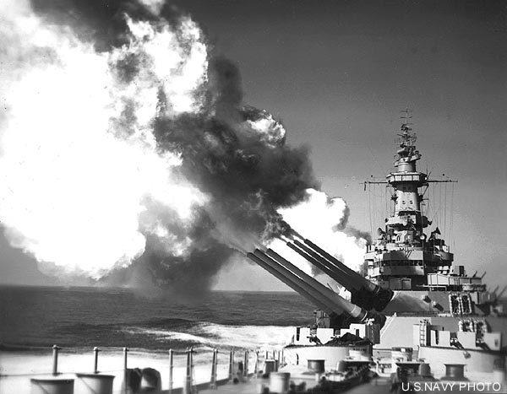
Prompt: Write salvo in a sentence with context clues.

19. vigilant: adjective- wide-awake, alert, watchful
synonym: attentive, on one’s toes
antonym: sleepy, inattentive, unobservant

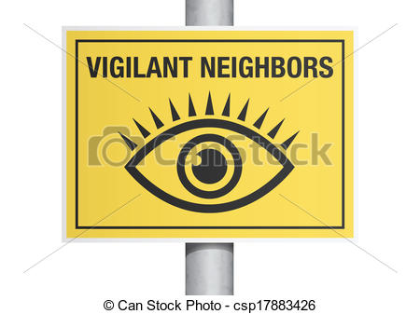
Prompt: What is a job that requires a vigilant employee?

20. wrath: noun- intense anger
synonym: rage, fury, ire, choler, indignation
antonym: favor, approval, pleasure, blessing
Prompt: When was the last time you felt someone’s wrath?

