Vocab B3 Part 2

- luster (n.) the quality of giving off light, brightness, glitter, brilliance
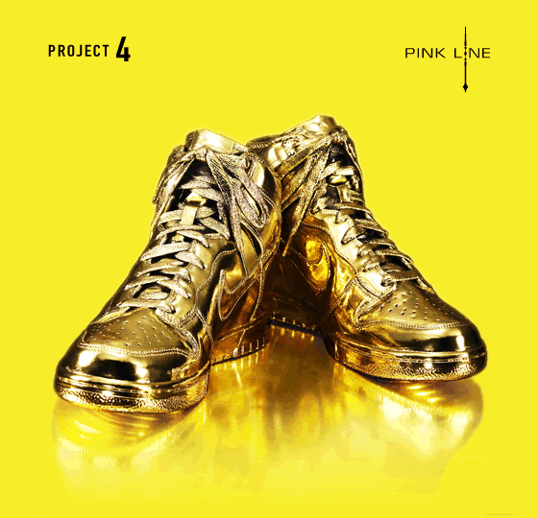
Syn: gloss, sheen, shine
Ant: tarnish, dullness
Prompt: List three things that have a luster when placed in the sunlight.

miscellaneous (adj.) mixed, of different kinds
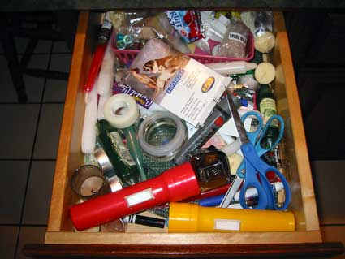
Syn: varied, assorted, motley
Ant: identical, uniform, homogeneous
Prompt: List three miscellaneous items you might find in your backpack.

oration (n.) a public speech for a formal occasion
Syn: address, harangue

Prompt: Why do you think most people are afraid of oration?

peevish (adj.) cross, complaining, irritable; contrary
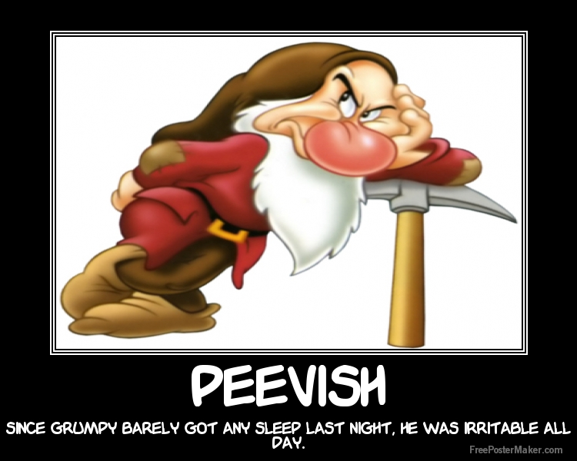
Syn: crabby, cranky, testy, stubborn
Ant: agreeable, amiable, even-tempered, pleasant

Prompt: What makes you peevish?

15. seethe (v.) to boil or foam; to be excited or disturbed
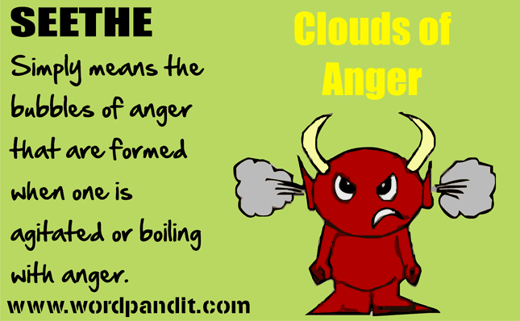
Syn: churn, simmer, stew

Prompt: What makes you seethe?
16. singe (v.) to burn slightly; (n.) a burn at the ends or edges
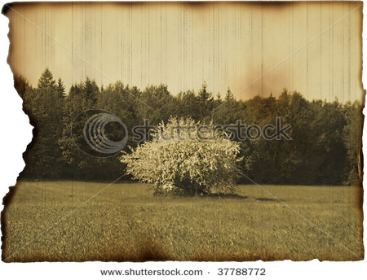
Syn: scorch, char, sear
Ant: incinerate
Prompt: What does singed hair smell like?

unique (adj.)one of a kind; unequaled; unusual; found only in a given
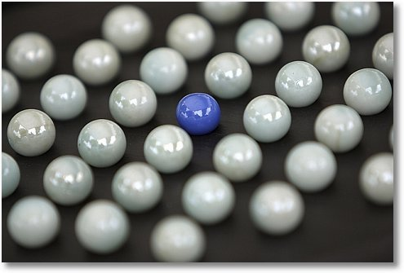
Syn: unparalleled, distinctive, singular
Ant: ordinary, commonplace, run-of-the-mill
Prompt: What makes you unique?

upright (adj.) vertical, straight; good, honest; (adv.) in a vertical position
Syn: perpendicular, virtuous
Ant: horizontal, prone, dishonest, corrupt

Prompt: Who is the most upright person you know? Explain.

verify (v.) to establish the truth or accuracy of, confirm
Syn: prove, validate, substantiate
Ant: disprove, refute, discredit

Prompt: How could you verify your age to an authority figure?

yearn (v.) to have a strong and earnest desire
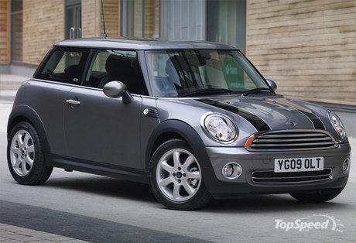
Syn: crave, long for, want

Prompt: What car do you yearn for?

