Vocab B4 Part 2

- mortify - to hurt someone's feelings deeply; to cause embarrassment or humiliation;
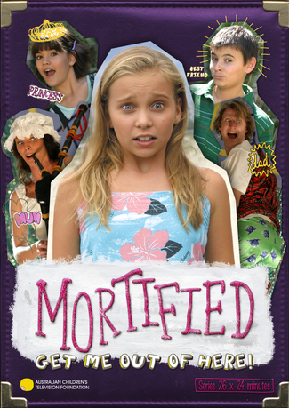
Syn: humiliate, embarrass, abash
Ant: (none)

Prompt: Describe a time when you were mortified by something your parents did or said in public.
- orthodox - in agreement with generally accepted beliefs or ways of doing things
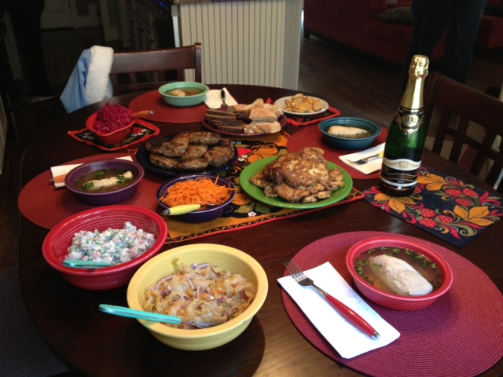
Syn: traditional, standard, customary
Ant: unusual, unconventional, heretical
Write down one orthodox thing people do during the holidays.

- procure to obtain through special effort; to bring about
Syn: gain, acquire, achieve
Ant: (none)

Prompt: How much money would you need to obtain your favorite video game, shoes, or t-shirt?

- Scurry - to run quickly, scamper, hurry
Like students waiting for the end of the day
bell and they scurry off to go home.

Syn: rush, dash, scramble
Ant: trudge, plod, creep, crawl

Prompt: Explain why students scurry in the hallway after the 2:15 bell rings.

- Sodden - soaked with liquid or moisture; expressionless, dull; spiritless, listless
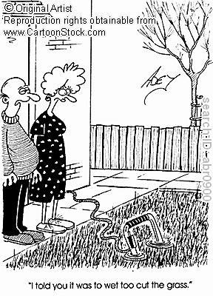
Syn: drenched, waterlogged, saturated
Ant: parched, arid

Prompt: Explain why a person might be sodden.

- spirited - full of life and vigor; courageous

Syn: lively, animated, gallant
Ant: lifeless, dull, lackluster

Prompt: Who is the most spirited person you know? EXPLAIN!

- Virtual - having a certain force or effect in fact but not in name; close to the real thing
Syn: functioning as, equivalent to
Ant: (none)

Prompt: Name a virtual reality game people play.

- Void - completely empty; having no legal force or effect; empty or unfilled space; to cancel or nullify
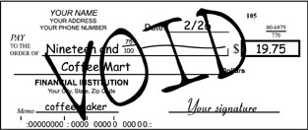
Syn: invalid, vacant, bare
Ant: in effect, teeming with, confirm

Prompt: What would it take for you to void your friendship with your best friend?

- wayward - disobedient, willful; unpredictable, capricious
Syn: perverse
Ant: docile, well-behaved, predictable

Prompt: What would happen to you if you were a wayward child?

- wince - to draw back suddenly, as though in pain or fear; the act of drawing back in this way
Syn: flinch, shudder, recoil
Ant: (none)

Prompt: Describe something that would make you wince in pain.

